

#include <bits/stdc++.h>
using namespace std;
void sortByRatio(double profit[], double weight[], int n)
{
for (int i = 0; i < n; i++)
{
for (int j = 0; j < n - i - 1; j++)
{
if ((profit[j] / weight[j]) < (profit[j + 1] / weight[j + 1]))
{
double temp1=profit[j];
profit[j]=profit[j+1];
profit[j+1]=temp1;

double temp2=weight[j];
weight[j]=weight[j+1];
weight[j+1]=temp2; }
}
}
}
double fractionalKnapsack(double profit[], double weight[], double frac[], int n, double W)
{
double totalProfit = 0.0;
for (int i = 0; i < n; i++)
{
if (W == 0) //W=maximum weight,Capacity
{
frac[i] = 0.0;
continue;
}
if (weight[i] <= W)
{
frac[i] = 1.0;
totalProfit += profit[i];
W -= weight[i];
}
else
{
frac[i] = W / weight[i];
totalProfit += profit[i] * frac[i];
W = 0;
}
}
return totalProfit;
}
int main()
{
int n;
double W;
cout << "Enter number of items: ";
cin >> n;
cout << "Enter knapsack capacity: ";
cin >> W;
double profit[100], weight[100], frac[100];
for (int i = 0; i < n; i++)
{
cout << "Enter profit and weight of item " << i + 1 << ": ";
cin >> profit[i] >> weight[i];
frac[i] = 0.0;
}
if (W == 0)
{
cout << fixed << setprecision(2);
cout << "Maximum Profit: 0.00" << endl;
cout << "Fractions: ";
for (int i = 0; i < n; i++)
cout << "0.00 ";

cout << endl;
return 0;
}
sortByRatio(profit, weight, n);
double totalProfit = fractionalKnapsack(profit, weight, frac, n, W);
cout << fixed << setprecision(2);
cout << "Maximum Profit: " << totalProfit << endl;
cout << "Fractions: ";
for (int i = 0; i < n; i++)
cout << frac[i] << " ";
cout << endl;
}
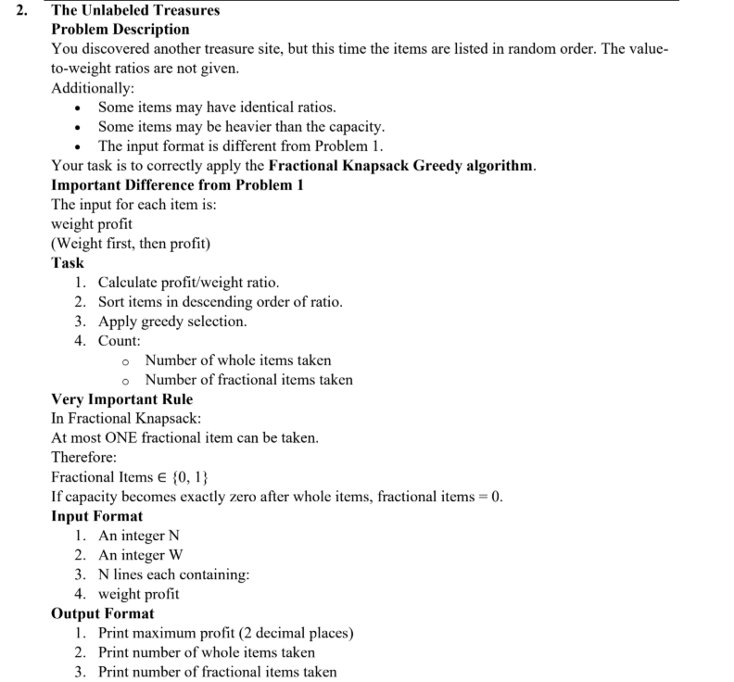
#include <bits/stdc++.h>
using namespace std;
void sortByRatio(double weight[], double profit[], int n){
for (int i = 0; i < n; i++){
for (int j = i + 1; j < n-i-1; j++){
if ((profit[j] / weight[j]) < (profit[j+1] / weight[j+1])){
double temp1 = profit[j];
profit[j] = profit[j+1];
profit[j+1] = temp1;

double temp2 = weight[j];
weight[j] = weight[j+1];
weight[j+1] = temp2;
}
}
}
}
double fractionalKnapsack(double weight[], double profit[], int n, double W,
int &wholeItems, int &fractionalItems)
{
double totalProfit = 0.0;
wholeItems = 0;
fractionalItems = 0;
for (int i = 0; i < n; i++)
{
if (W == 0)
break;

if (weight[i] <= W)
{
totalProfit += profit[i];
W -= weight[i];
wholeItems++;
}
else
{
totalProfit = totalProfit + profit[i] * (W / weight[i]);
fractionalItems = 1;
W = 0;
}
}
return totalProfit;
}
int main()
{
int n;
double W;
cout << "Enter number of items: ";
cin >> n;
cout << "Enter knapsack capacity: ";
cin >> W;
double weight[100], profit[100];
for (int i = 0; i < n; i++)
{
cout << "Enter weight of item " << i + 1 << ": ";
cin >> weight[i];
cout << "Enter profit of item " << i + 1 << ": ";
cin >> profit[i];
}
sortByRatio(weight, profit, n);
int wholeItems, fractionalItems;
double totalProfit = fractionalKnapsack(weight, profit, n, W,
wholeItems, fractionalItems);
cout << fixed << setprecision(2);
cout << "Maximum Profit: " << totalProfit << endl;
cout << "Whole Items: " << wholeItems << endl;
cout << "Fractional Items: " << fractionalItems << endl;
return 0;
}

3.
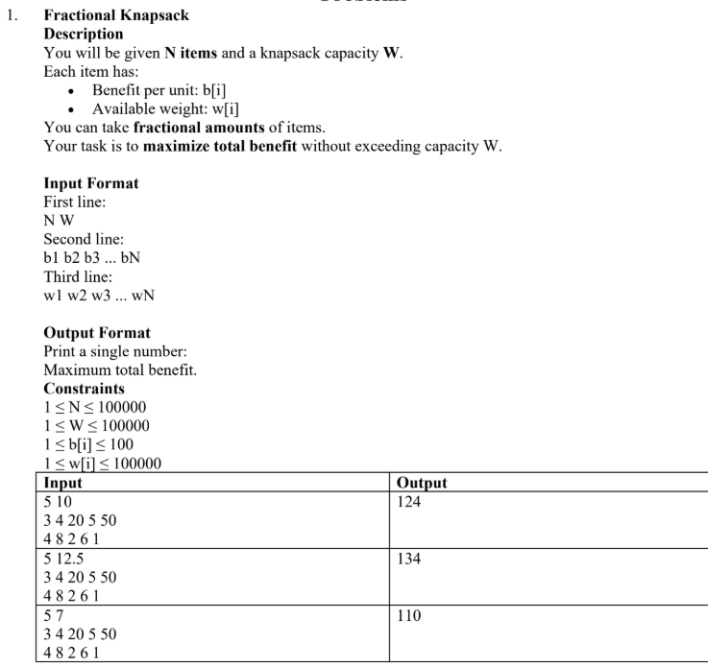
#include <bits/stdc++.h>
using namespace std;
void sortByRatioDescending(int n,double benefit[], double weight[]){
for(int i=0;i<n-1;i++){
for(int j=0;j<n-i-1;j++){
if (benefit[j] < benefit[j + 1]) {

double temp1=benefit[j];
benefit[j]=benefit[j+1];
benefit[j+1]=temp1;

double temp2=weight[j];
weight[j]=weight[j+1];
weight[j+1]=temp2;
}
}
}
}
double FractionalKnapsack(int n, double benefit[],double weight[], double capacity){
double totalProfit = 0.0;
for(int i=0;i<n;i++){
if(weight[i]<=capacity){
capacity = capacity - weight[i];
totalProfit = totalProfit + benefit[i]* weight[i];
}else{
totalProfit = totalProfit + (benefit[i] *weight[i] )*(capacity / weight[i]);
break;
}
}
return totalProfit;
}
int main(){
int n;
double capacity;
cout << "Enter number of items: ";
cin>> n;
double benefit[n];
double weight[n];
cout << "Enter capacity: ";
cin >> capacity;
cout << "Enter benefits: ";
for(int i=0;i<n;i++){
cin>>benefit[i];
}
cout << "Enter weights: ";
for(int i=0;i<n;i++){
cin>>weight[i];
}
sortByRatioDescending(n,benefit,weight);
double result = FractionalKnapsack(n,benefit,weight,capacity);
cout << result << endl;
}

#include <bits/stdc++.h>
using namespace std;
void sortByRatio(double profit[], double weight[], int n) {
for (int i = 0; i < n - 1; i++) {
for (int j = 0; j < n - i - 1; j++) {
double ratio1 = profit[j] / weight[j];
double ratio2 = profit[j + 1] / weight[j + 1];

if (ratio1 < ratio2) {
swap(profit[j], profit[j + 1]);
swap(weight[j], weight[j + 1]);
}
}
}
}
double fractionalKnapsack(int n, double capacity,
double profit[], double weight[]) {
double totalProfit = 0.0;
sortByRatio(profit, weight, n);
for (int i = 0; i < n; i++) {
if (weight[i] <= capacity) {
capacity -= weight[i];
totalProfit += profit[i];
} else {
totalProfit += profit[i] * (capacity / weight[i]);
break;
}
}
return totalProfit;
}
int main() {
int n;
double capacity;
cin >> n >> capacity;
double profit[1000], weight[1000];
for (int i = 0; i < n; i++)
cin >> profit[i];
for (int i = 0; i < n; i++)
cin >> weight[i];
double result = fractionalKnapsack(n, capacity, profit, weight);
cout << result << endl;
}

